Promoție
Va rog la comanda sa specificati ca este din promotie!
Unele produse sunt LIMITATE! sunt la lichidare stoc!

spray de marcare
ACN7326401A - LM-90 LINE MARKING PAINT750mlAEROSOL YELLOW RAL 1018
ACN7326401C - LM-90 LINE MARKING PAINT750mlAEROSOL WHITE RAL 9003
ACN7326401E - LM-90 LINE MARKING PAINT750mlAEROSOL RED RAL 3018
ACN7326401F - LM-90 LINE MARKING PAINT750mlAEROSOL BLUE RAL 5015
ACN7326401H - LM-90 LINE MARKING PAINT750mlAEROSOL GREEN RAL 6018
ACN7326401K - LM-90 LINE MARKING PAINT750mlAEROSOL ORANGE RAL 2003
Pret de achizitie special 27 lei/buc+TVA.
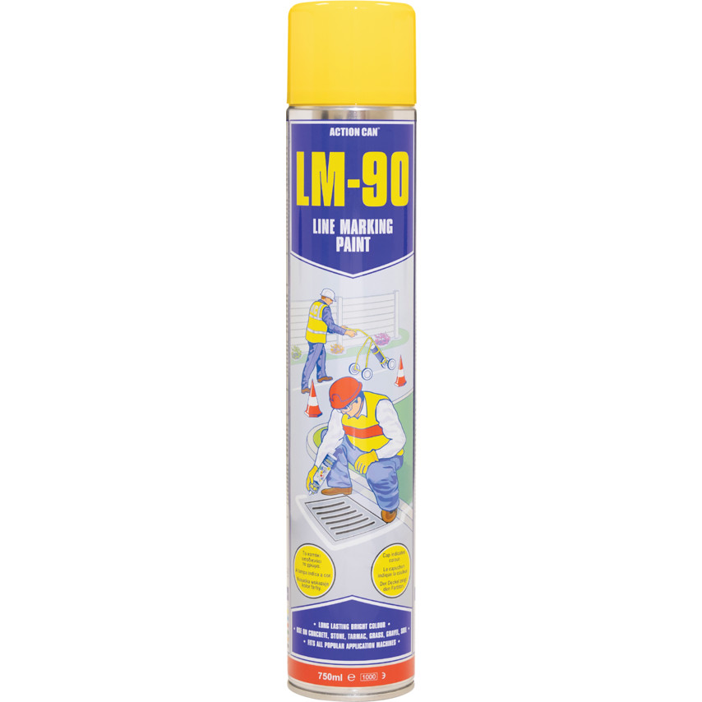
https://www.cromwell.co.uk/shop/lubricants-and-chemicals/line-markers/lm-90-line-marking-spray-paint-yellow-aerosol-750ml/p/ACN7326401A?query=ACN7326401A&preventRedirect=true

AVN8350870K - STRAP & SEAL KIT 800M STRAP + 300SEALS
Pret de achizitie special 159 lei/kit+TVA.
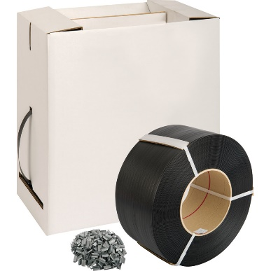
https://www.cromwell.co.uk/shop/storage-handling-and-packaging/strapping-dispensers/strap-and-seal-kit-800m-strap-300-seals/p/AVN8350870K?query=AVN8350870K&preventRedirect=true

KBE2825400K - COB LED SINGLE HEAD WORKLIGHT 20W 1400Lm 240V
Pret de achizitie special 175 lei/buc+TVA.
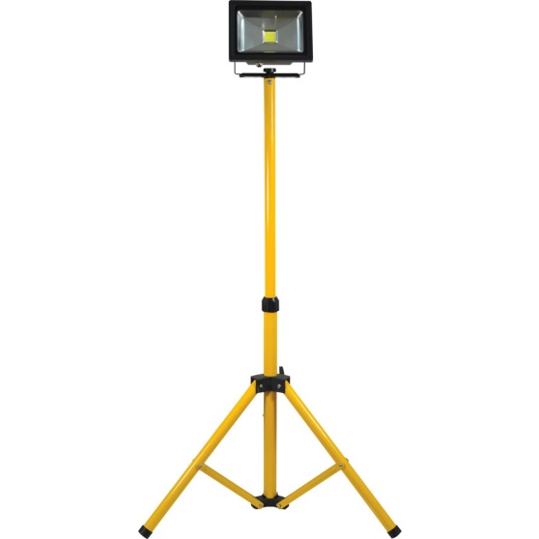
https://www.cromwell.co.uk/shop/electrical-and-lighting/site-lights/cob-led-single-head-worklight-20w-1400lm-240v/p/KBE2825400K?query=KBE2825400K&preventRedirect=true

KBE2825420K - COB LED TWIN HEAD WORKLIGHT 20W 1400Lm 240V
Pret de achizitie special 290 lei/buc+TVA.
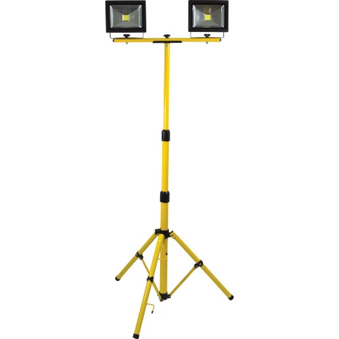
https://www.cromwell.co.uk/shop/electrical-and-lighting/site-lights/cob-led-twin-head-worklight-20w-1400lm-240v/p/KBE2825420K?query=KBE2825420K&preventRedirect=true
KBE2825500K - RECHARGEABLE COB LED PORTABLE WORKLIGHT 700lm
Pret de achizitie special 160 lei/buc+TVA.
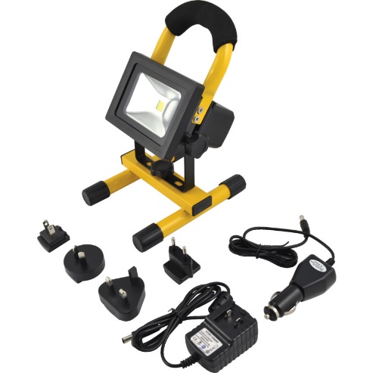
https://www.cromwell.co.uk/shop/electrical-and-lighting/floodlights/rechargeable-cob-led-portable-worklight/p/KBE2825500K?query=KBE2825500K&preventRedirect=true

KEN5331840K - 130MM GLASS & TILE CUTTER
Pret de achizitie special 5,50 lei/buc+TVA.
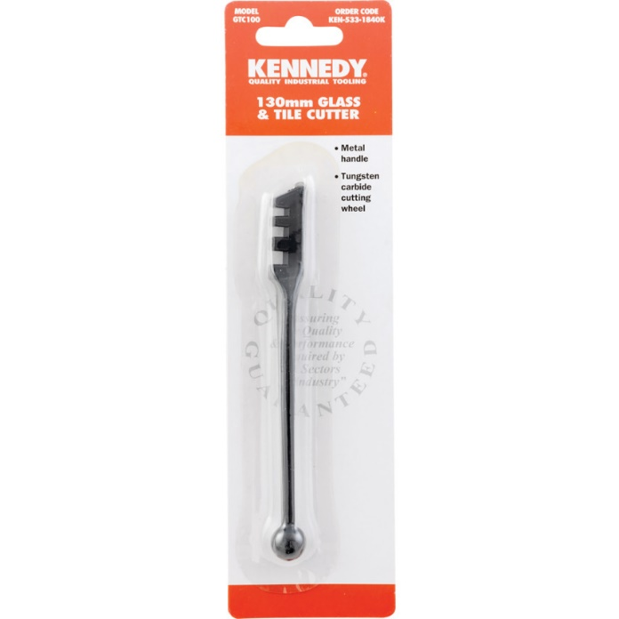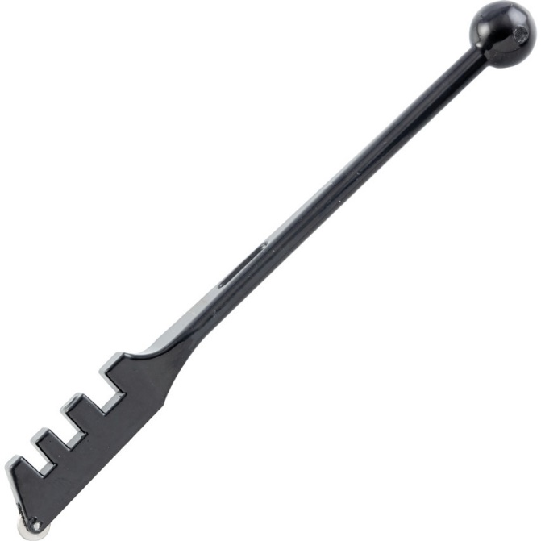
https://www.cromwell.co.uk/shop/hand-tools/tiling-and-glazing/tile-cutter-compatible-with-ceramic-tile-glass-130mm/p/KEN5331840K?query=KEN5331840K&preventRedirect=true

KEN5382820K - KENNEDY PROFESSIONAL QUICK RELASEHACKSAW
Pret de achizitie special 68 lei/buc+TVA.
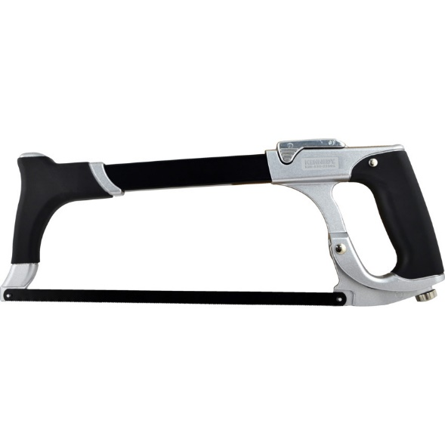
https://www.cromwell.co.uk/shop/hand-tools/hand-saws/hacksaw-300mm-blade-bi-metal/p/KEN5382820K?query=KEN5382820K&preventRedirect=true

KEN5400251K - LG400 400cc GREASE GUN
Pret de achizitie special 58 lei/buc+TVA.
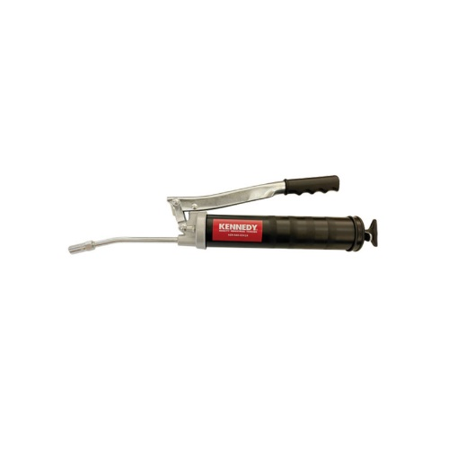
https://www.cromwell.co.uk/shop/lubricants-and-chemicals/grease-guns/side-lever-grease-gun-500cc-bulk-cartridge-suction/p/KEN5400341K?query=KEN5400341K&preventRedirect=true

KEN5826390K - 1/2" – 420mm SQ DR FLEX HEAD STANDARDR/HANDLE
Pret de achizitie special 85 lei/buc+TVA.
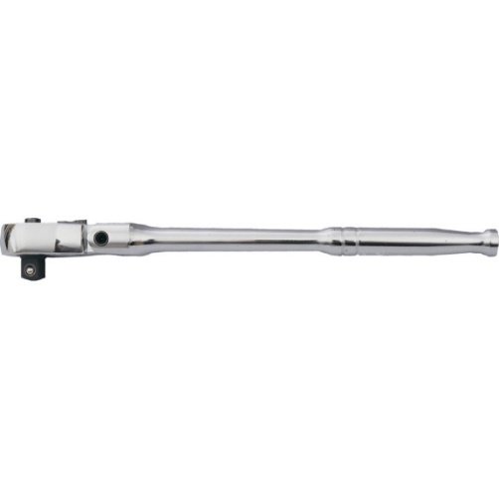
https://www.cromwell.co.uk/shop/hand-tools/socket-accessories/1-2in-ratchet-handle-420mm/p/KEN5826390K?query=KEN5826390K&preventRedirect=true

KEN5839210K - PM9M 1/2" SQUARE DRIVE IMPACTSOCKET SET 9PC (10-30mm)
Pret de achizitie special 80 lei/set+TVA.
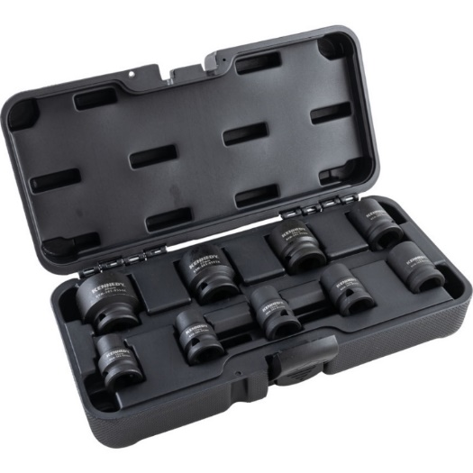
https://www.cromwell.co.uk/shop/hand-tools/impact-socket-sets/1-2in-drive-impact-socket-set-9-piece-metric/p/KEN5839210K?query=KEN5839210K&preventRedirect=true

KEN5885500K - 3-30mmx150mm TUBE CUTTER
Pret de achizitie special 17 lei/buc+TVA.
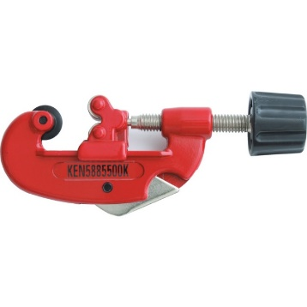
https://www.cromwell.co.uk/shop/hand-tools/pipe-cutters/3-to-30mm-brass-copper-stainless-steel-single-stroke-tube-cutter/p/KEN5885500K?query=KEN5885500K&preventRedirect=true
MTL9851650K - MINI COMPACT SACK TRUCK 60KG CAPACITY
Pret de achizitie special 190 lei/buc+TVA.
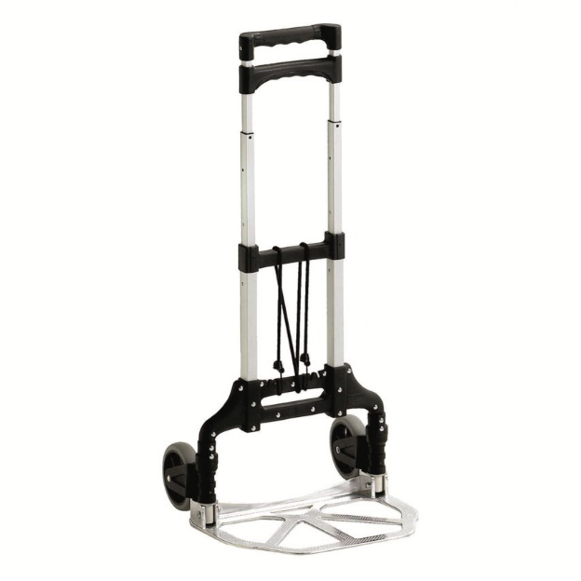
https://www.cromwell.co.uk/shop/storage-handling-and-packaging/sack-trucks/mini-compact-sack-truck-60kg-capacity/p/MTL9851650K?query=MTL9851650K&preventRedirect=true

MTL9851660K - COMPACT SACK TRUCK 90KG CAPACITY
Pret de achizitie special 190 lei/buc+TVA.
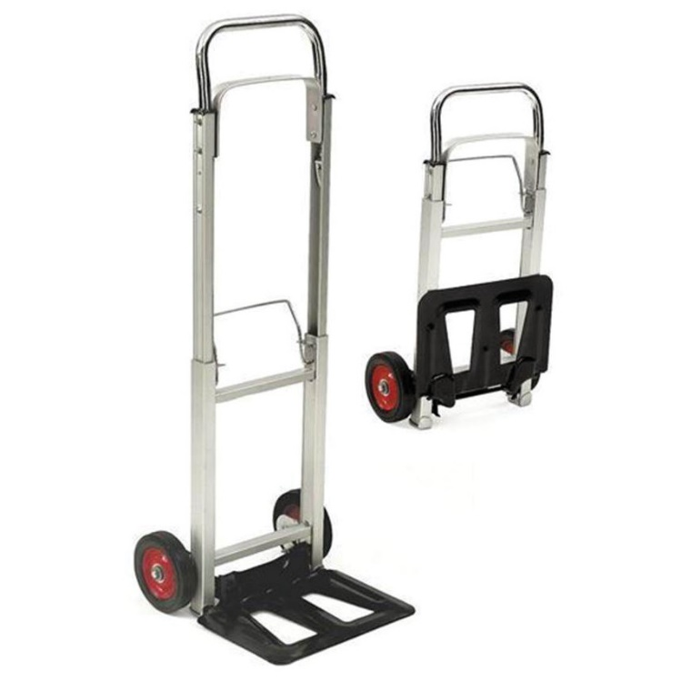
https://www.cromwell.co.uk/shop/storage-handling-and-packaging/sack-trucks/compact-sack-truck-90kg-capacity/p/MTL9851660K?query=MTL9851660K&preventRedirect=true
SSF9607710K - SIRIUS-CLEAR A/FOG SCRATCH RESISTSAFETY GLASSES
Pret de achizitie special 5,50 lei/buc+TVA.
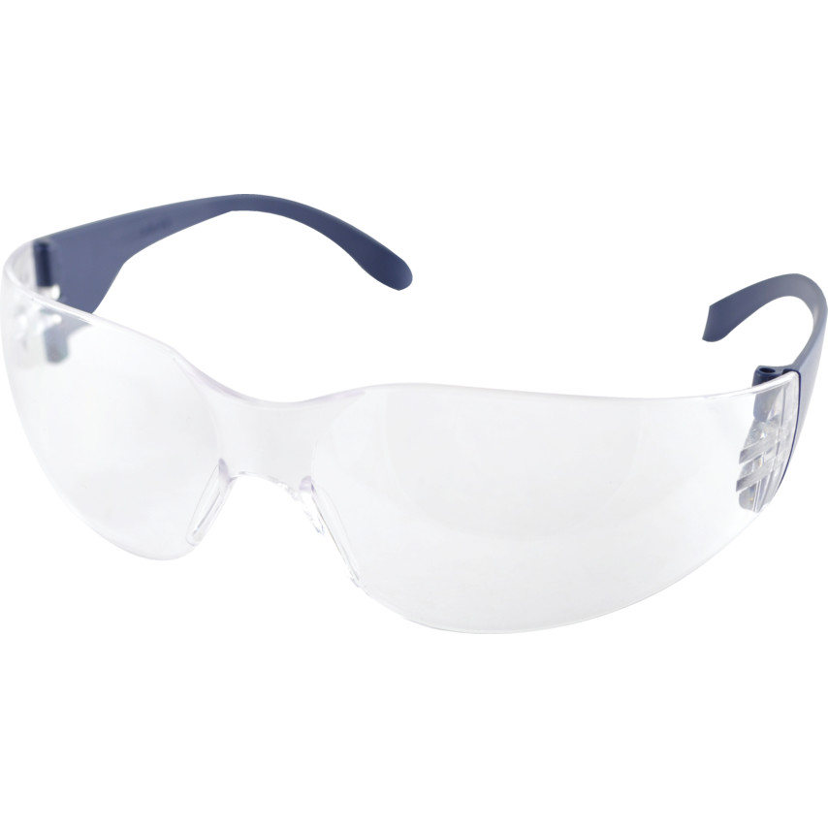
https://www.cromwell.co.uk/shop/personal-protection-and-clothing/safety-glasses/sirius-safety-glasses-clear-lens-frameless-blue-frame-anti-fog-scratch-resistant-uv-resistant/p/SSF9607710K?query=SSF9607710K&preventRedirect=true

YMT5820001H - SWIVEL HANDLE 1/4" SQ DR 150mm
Pret de achizitie special 16 lei/buc+TVA.
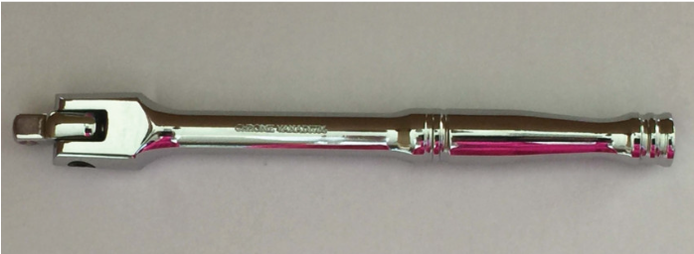
https://www.cromwell.co.uk/shop/hand-tools/socket-accessories/1-4in-swivel-handle-150mm/p/YMT5820001H?query=YMT5820001H&preventRedirect=true

SEN5885508K - 8"/200mm LEADER PATTERN PIPE WRENCH
Pret de achizitie special 13 lei/buc+TVA.

SEN5885510K - 10"/250mm LEADER PATTERNPIPE WRENCH
Pret de achizitie special 18 lei/buc+TVA.

SEN5885512K - 12"/300mm LEADER PATTERNPIPE WRENCH
Pret de achizitie special 23 lei/buc+TVA.

SEN5885514K - 14"/350mm LEADER PATTERNPIPE WRENCH
Pret de achizitie special 33 lei/buc+TVA.

SEN5885518K - 18"/450mm LEADER PATTERNPIPE WRENCH
Pret de achizitie special 40 lei/buc+TVA.

SEN5885524K - 24"/600mm LEADER PATTERNPIPE WRENCH
Pret de achizitie special 55 lei/buc+TVA.

SEN5885536K - 36"/900mm LEADER PATTERN PIPEWRENCH
Pret de achizitie special 100 lei/buc+TVA.

SEN5885548K - 48"/1220mm LEADER PATTERN PIPEWRENCH
Pret de achizitie special 155 lei/buc+TVA.
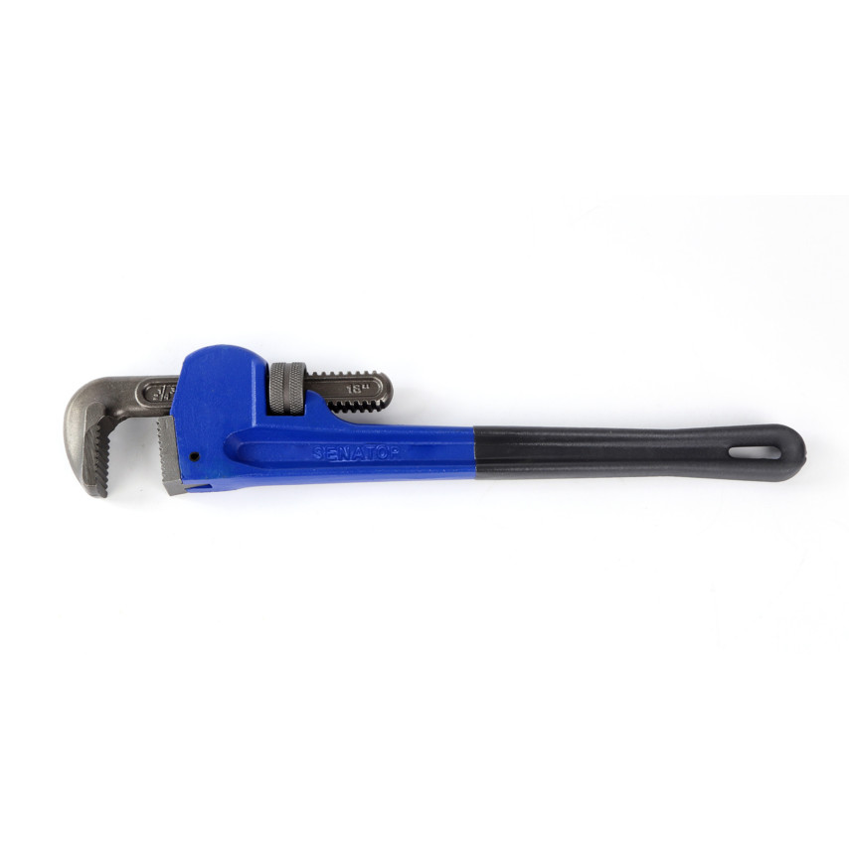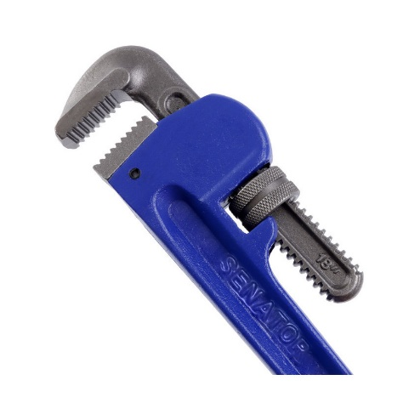
https://www.cromwell.co.uk/shop/hand-tools/pipe-wrenches/140mm-leader-pattern-pipe-wrench-1200mm/p/SEN5885548K?query=SEN5885548K&preventRedirect=true

KEN5390500K -160x80mm T-HANDLE GENERALUSE CLAMP
Pret de achizitie special 54 lei/buc+TVA.

KEN5390520K - 200x100mm T-HANDLE GENERAL USE CLAMP
Pret de achizitie special 80 lei/buc+TVA.

KEN5390540K - 250x120mm T-HANDLE GENERAL USE CLAMP
Pret de achizitie special 85 lei/buc+TVA.

KEN5390560K - 300x140mm T-HANDLE GENERAL USE CLAMP
Pret de achizitie special 115 lei/buc+TVA.

KEN5390580K - 400x120mm T-HANDLE GENERAL USE CLAMP
Pret de achizitie special 120 lei/buc+TVA.

KEN5390600K - 500x120mm T-HANDLE GENERAL USE CLAMP
Pret de achizitie special 130 lei/buc+TVA.

KEN5390620K - 600x120mm T-HANDLE GENERAL USE CLAMP
Pret de achizitie special 137 lei/buc+TVA.
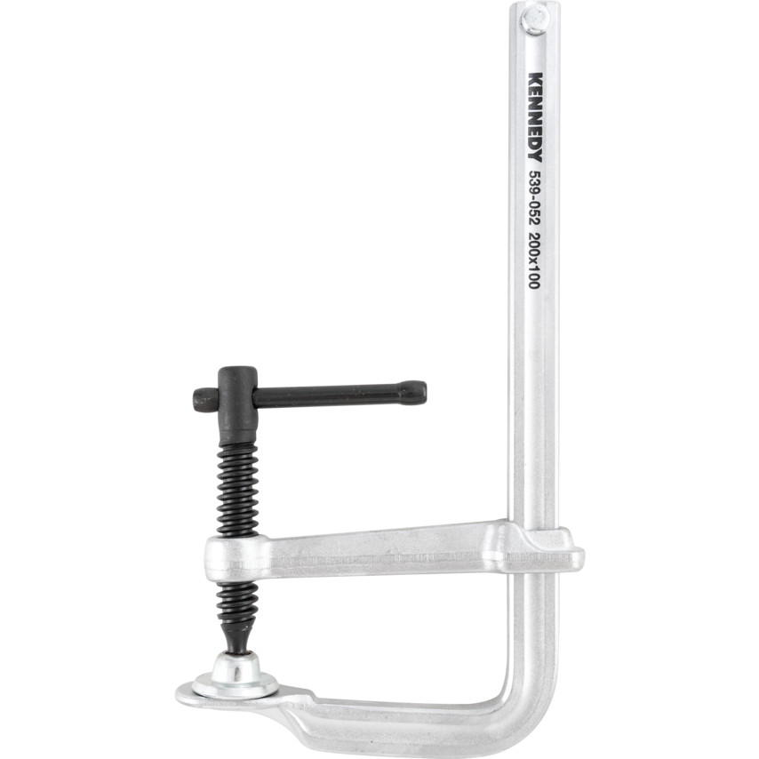
https://www.cromwell.co.uk/shop/hand-tools/clamps/f-clamp-600mm-x-120mm-ergonomic-handle/p/KEN5390620K?query=KEN5390620K&preventRedirect=true
YRK2207317E - 125x22mm F/GLASS ZIRC FLAP DISC P40
Pret de achizitie special 3,50 lei/buc+TVA.

YRK2207317J - 125x22mm F/GLASS ZIRC FLAP DISC P60
Pret de achizitie special 3,50 lei/buc+TVA.

YRK2207317Q - 125x22mm F/GLASS ZIRC FLAP DISC P120
Pret de achizitie special 3,50 lei/buc+TVA.
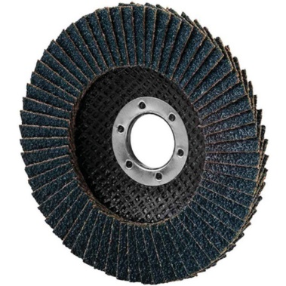
https://www.cromwell.co.uk/shop/abrasives/flap-discs/125x22mm-f-glass-zirc-flap-disc-p120/p/YRK2207317Q?query=YRK2207317Q&preventRedirect=true

manusi negre Polyuretan marimi 8,9,10,11
Pret de achizitie special 2,30 lei/per.+TVA.
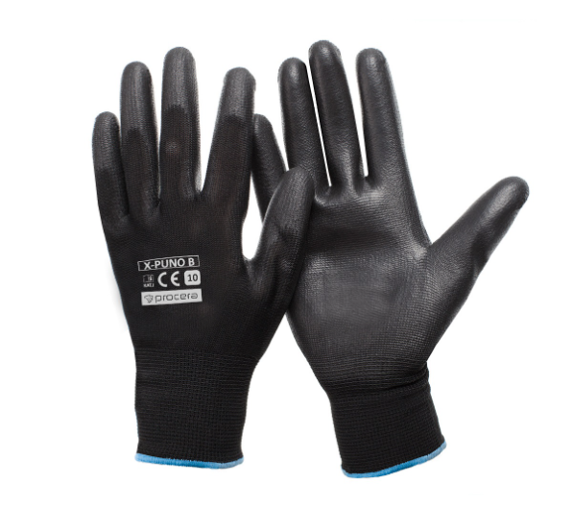

KBE2702543K - GM5603 MICRO AIR DIE GRINDER
Pret de achizitie special 285 lei/buc+TVA.
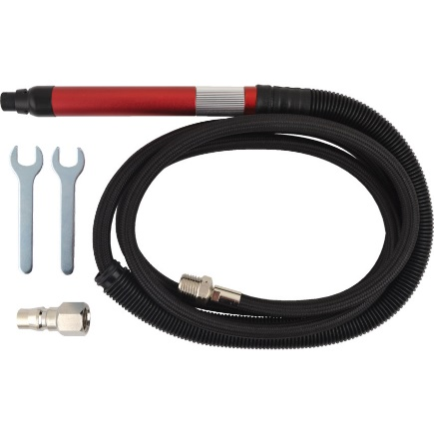
https://www.cromwell.co.uk/shop/power-tools/die-grinders/mg-056-3-micro-air-die-grinder-kit-with-3-0mm-collet-and-silencer-58000rpm/p/KBE2702543K?query=KBE2702543K&preventRedirect=true
SSF9464650R - 530mmx360mm KNEE SAVER MAT
Pret de achizitie special 53 lei/buc+TVA.
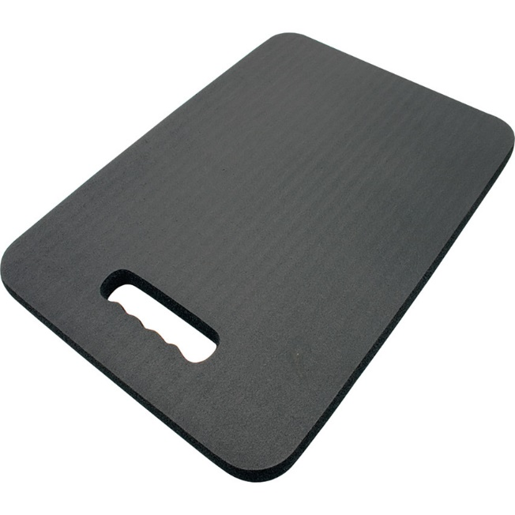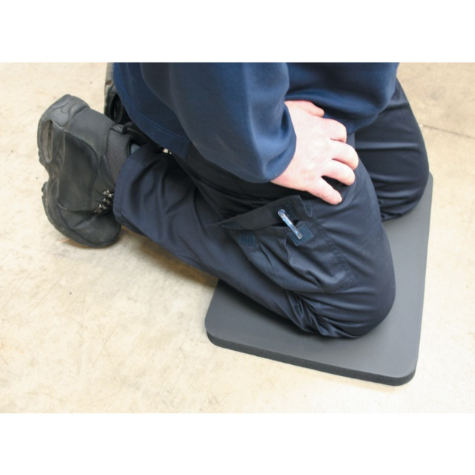

https://www.cromwell.co.uk/shop/personal-protection-and-clothing/kneeling-pads/kneeling-pad-black-nitrile-pvc-53cmx36cm/p/SSF9464650R?query=SSF9464650R&preventRedirect=true

SSF9468460F - 0.9Mx1.5M WORK MAT
Pret de achizitie special 245 lei/buc+TVA.
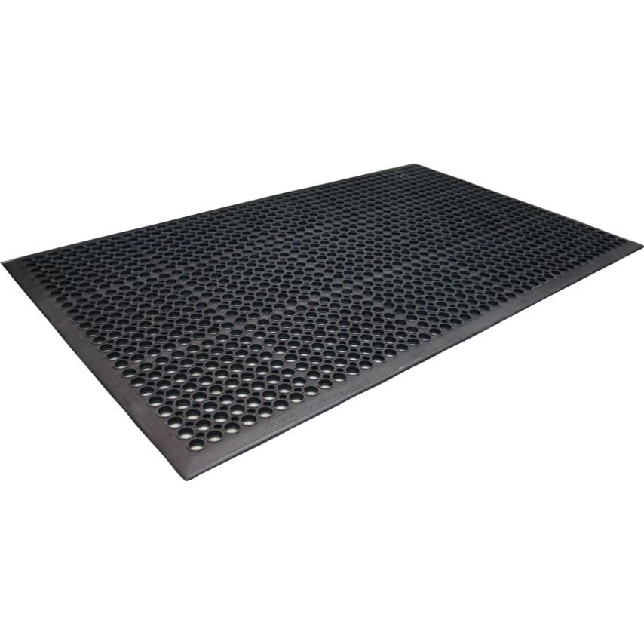
https://www.cromwell.co.uk/shop/site-safety/anti-fatigue-matting/0-9m-x-1-5m-work-mat/p/SSF9468460F?query=SSF9468460F&preventRedirect=true

SSF9468523K - 0.9Mx1.2M BUBBLE STAND MATTING
Pret de achizitie special 260 lei/buc+TVA.
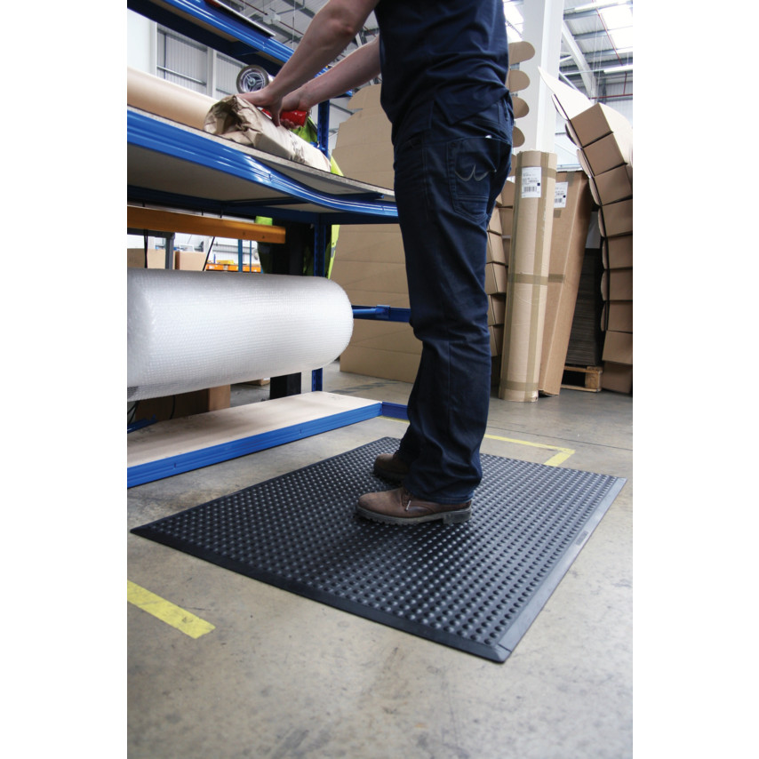
https://www.cromwell.co.uk/shop/site-safety/anti-fatigue-matting/0-9m-x-1-2m-bubble-stand-matting/p/SSF9468523K?query=SSF9468523K&preventRedirect=true

SSF9468706K - 0.6Mx0.9M BLACK/STEEL ENTRANCE MAT
Pret de achizitie special 90 lei/buc+TVA.
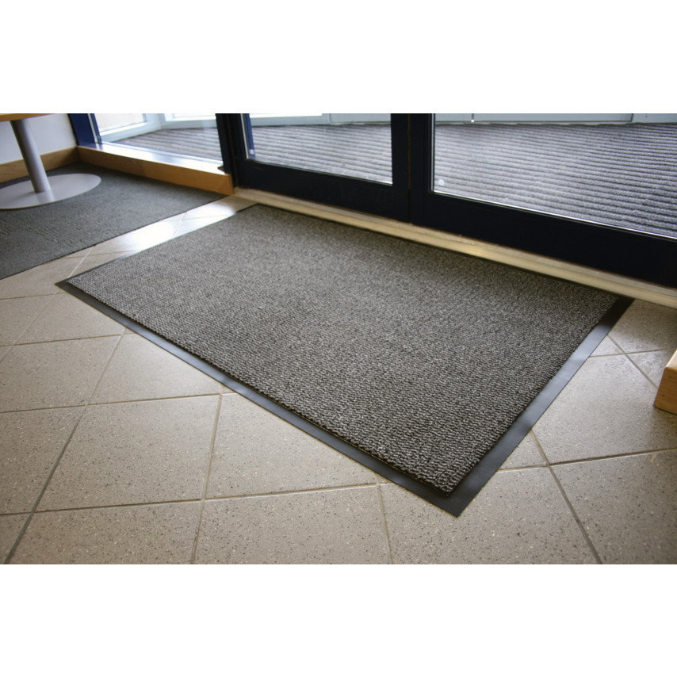
https://www.cromwell.co.uk/shop/site-safety/entrance-and-mud-remover-mats/0-6m-x-0-9m-steel-and-black-entrance-mat/p/SSF9468706K?query=SSF9468706K&preventRedirect=true
SOL7320840K - SW1-400C WELDERS ANTI-SPATTER SPRAY 400gm
Pret de achizitie special 16 lei/buc+TVA.
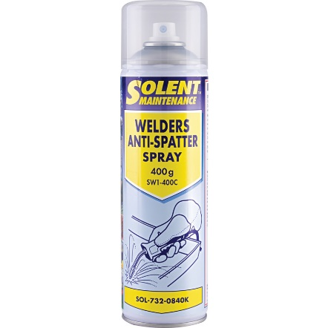
https://www.cromwell.co.uk/shop/lubricants-and-chemicals/anti-spatter/sw1-400c-anti-spatter-aerosol-400ml/p/SOL7320840K?query=SOL7320840K&preventRedirect=true

SOL7329300K - SW2-5000 WELDERS ANTI-SPATTER FLUID 5LTR
Pret de achizitie special 31 lei/buc+TVA.
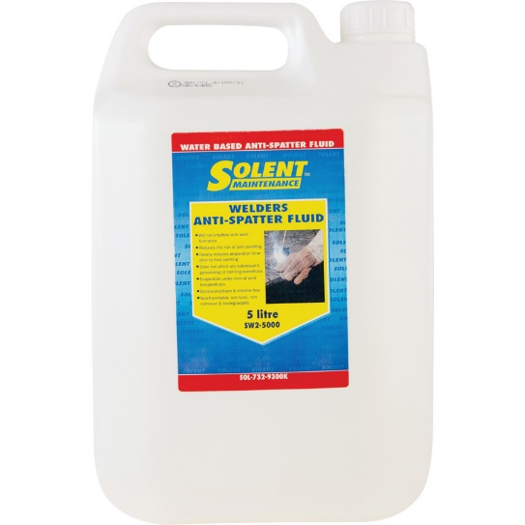
https://www.cromwell.co.uk/shop/lubricants-and-chemicals/anti-spatter/sw2-5000-welders-anti-spatter-fluid-bottle-5ltr/p/SOL7329300K?query=SOL7329300K&preventRedirect=true

KEN5405400K - 500ml INDUSTRIAL HAND SPRAYER HEAVY DUTY
Pret de achizitie special 4,50 lei/buc+TVA.
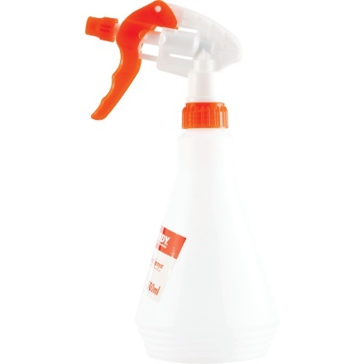
https://www.cromwell.co.uk/shop/lubricants-and-chemicals/oil-cans-and-guns/hand-sprayer-500ml-polyethylene/p/KEN5405400K?query=KEN5405400K&preventRedirect=true

SHR7324020K - SHERWOOD STD 500ml
Pret de achizitie special 38 lei/buc+TVA.
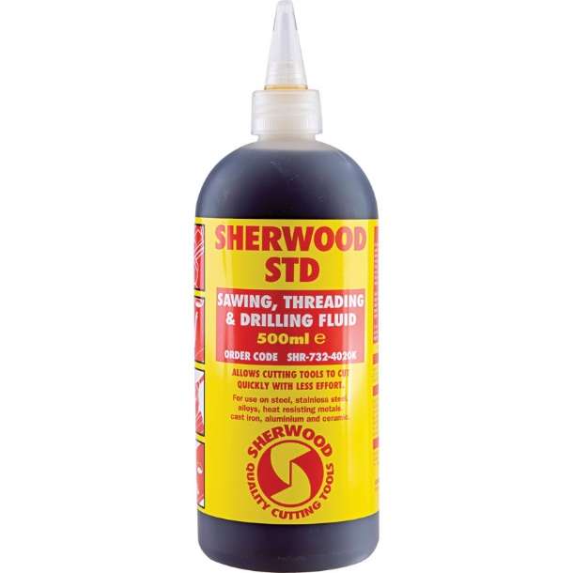
https://www.cromwell.co.uk/shop/lubricants-and-chemicals/cutting-and-coolant-fluids/std-tapping-and-drilling-non-soluble-fluid-500ml/p/SHR7324020K?query=SHR7324020K&preventRedirect=true

SHR7324060K - SHERWOOD STD 5LTR
Pret de achizitie special 380 lei/buc+TVA.
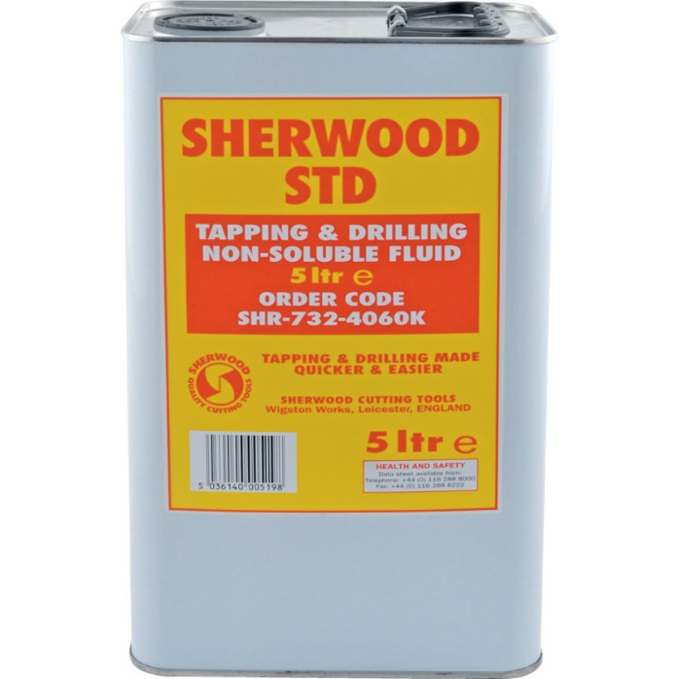
https://www.cromwell.co.uk/shop/lubricants-and-chemicals/cutting-and-coolant-fluids/std-tapping-and-drilling-non-soluble-fluid-5ltr/p/SHR7324060K?query=SHR7324060K&preventRedirect=true

